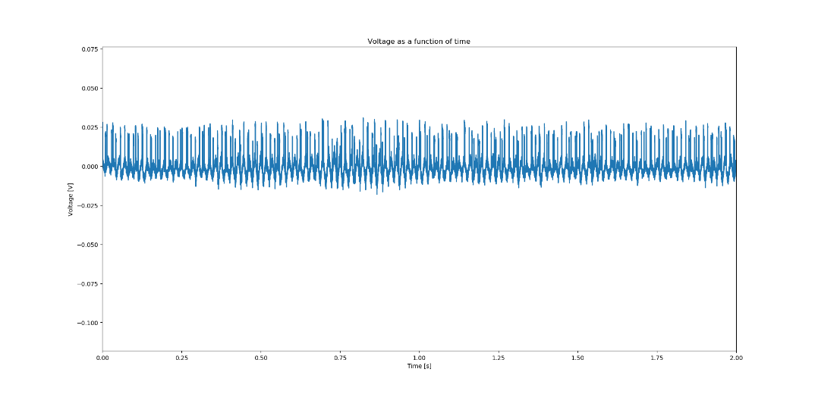

Figure : V on the time domain of bin 0

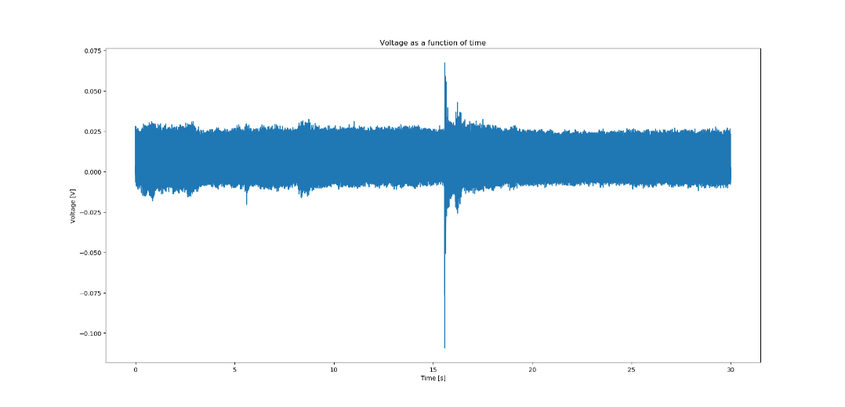

Figure : V on the time domain of all 15 bins

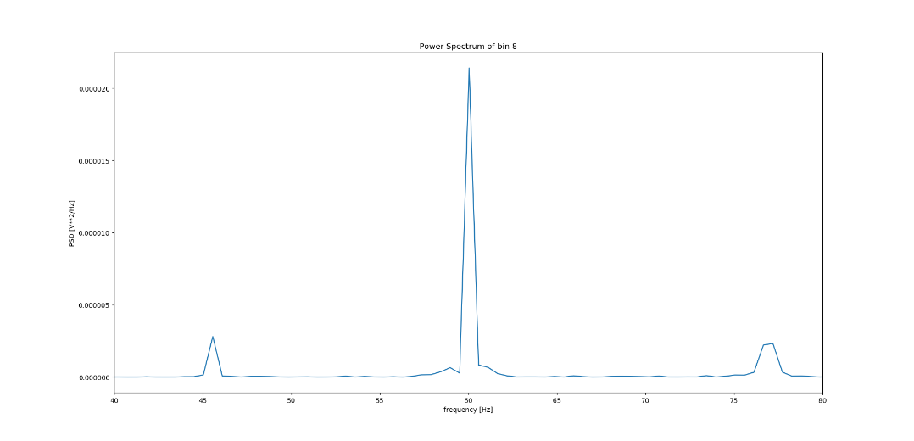

Figure : power spectrum of bin 8 of frequency ranges 45, 55, 65, and 75 hz (Note: there is a spike at 60 hz corresponding to equipments' operating frequency, but I don't use a frequency range that includes 60 hz)